


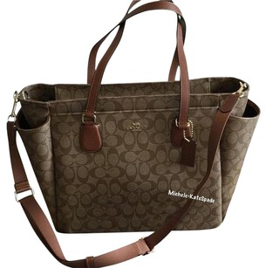
Saturday, May 20th, 2017
Freeland Event Center
526 Fern St.
Freeland, PA 18224

Doors open at 11 am – Bingo starts promptly at 12 noon
10 games of bingo * 5 specials + 1 jackpot game
(specials will be $5 at the door for all 5 games)

Tickets are $20 in advance until May 1st
$25 after and at the door if available
All ages welcome, but all entrants must have a ticket
Call or text Ashley at 570-926-5906 to order tickets
Tickets will also be on sale at the Laurel Mall on April 7 & 8 from 6-8 pm in the Boscov’s wing,
while supplies last

BINGO * FOOD * RAFFLES * DOOR PRIZES * BAKE SALE * TRICKY TRAYS *

All proceeds will be funding All American Girls Softball’s Bathroom Construction Project

